· Specification
Model |  | Push button | Roller lever |  | Lever |  | Roller push button
 |  | P501O | R504A | R504C | L507A | L507C | PR508V | PR508H
Appearance |  | 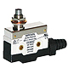 | 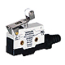 | 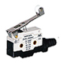 | 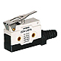 | 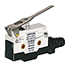 | 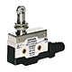 | 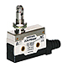
Operation speed |  | 0.1 mm - 0.5 m/s
Frequency | Mechanical | 120 / minute
Frequency | Electronical | 20 / minute
Insulation resistance |  | Min. 100 MΩ (At d.c 500 V)
Dielectric strength |  | Between charging part :1,000 V AC 50/60 ㎐ for 1 minute,  Between discharging part : 1,500 V AC 50/60 ㎐ for 1 minute
Contact resistance |  | Max. 25 mΩ (initial), Max. 100 mΩ
Vibration | Malfunction | 10 - 55 ㎐ double amplitude width 1.5 ㎜
Shock | Durability | Min. 1,000 ㎨ (Min. 100G)
Shock | Malfunction | Min. 300 ㎨ (Min. 30G)
Life | Mechanical | Min. 1 million operation
Life | Electrical | Min. 0.3 million operation
weight |  | Approx 1010 g (10 ZCN-PR508H 1 box)
Ambient temperature and humidity |  | -10 ℃ ~ +80 ℃ Max. 25 ~ 95 %R.H.

